www.orbostedcentre.org.au https://www.facebook.com/orbosteducationcentre

Detailed course flyers are available from our office

Expressions of interest to attend any of our courses can be registered at our office at any time.

Any courses not listed please discuss with our staff.

Nationally Accredited Training

The following courses are run at the centre on a regular basis:

First Aid Courses

CPR

First Aid Level II

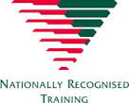
Anaphylaxis Management

Asthma Management

Hospitality Courses

Safe Food Handling

Responsible Service of Alcohol

Please call the centre on 51541788 for more information or to book a place.

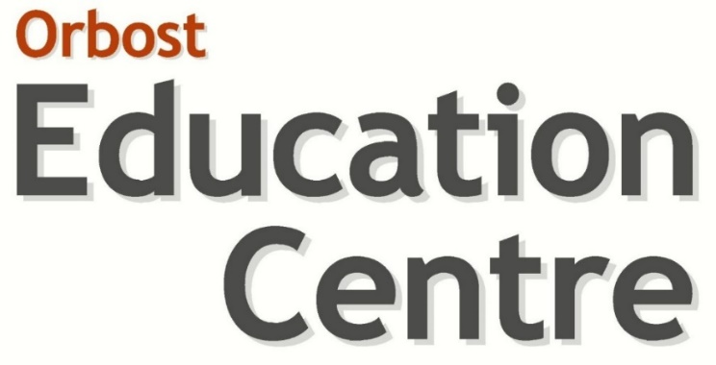

Course Guide

Proudly part of the community since 1976

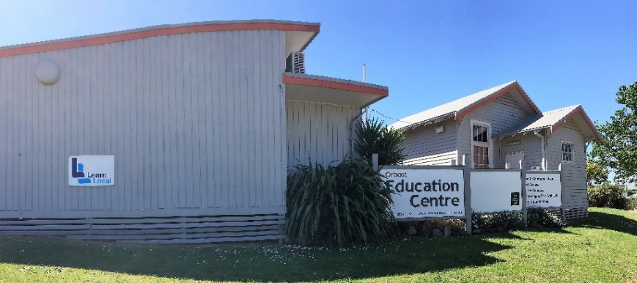

Take your next step with us!
As a Learn Local organisation, we offer a range of education and training programs designed to meet your learning needs. We can help you return to study, improve your reading, writing and maths skills, receive a qualification, gain employment or learn something new.
Leaning Changes Lives….
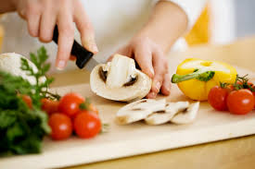
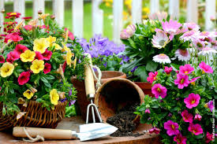

Pre-Accredited Courses

A Taste of Hospitality: (10 weekly sessions from 10 – 3pm)
Would you like to build on your cooking skills? The focus of this
course is to develop your confidence in the kitchen. The course will
include: working with others; planning healthy meals;health & safety
in the kitchen; safe food handling.

Computers/Ready to Work: (10 weekly sessions from 10 – 3pm)
Are you thinking about going back to work? Ready to Work/Computers is a work skills program that will help you impress future employers. Course sessions include: introduction to word; internet & email; job interview skills & resume preparation & writing.

Grow with your Garden: (10 weekly sessions from 10 – 3pm)
Want to learn new skills, start your own business or enrol in further
study? Come on down and learn in a fun garden environment.
Sessions will include: install garden irrigation; lay paving; plant trees
& shrubs; garden safety; identify plants and propagate cuttings.

Introduction to Floristry: (7 weekly sessions from 10 – 3pm)
Would you like to learn how to create hand tied posies & stunning
centre pieces? Start your career in floristry? This course covers:
flower identification & storage; basic flower handling & use of floristry
tools.

Intro to Construction & Painting: (10 weekly sessions from 10 – 3pm)
Climb the ladder to a colourful career. Work with your hands while you
learn new skills. This project-based program will include: plan organise
work; use of small hand tools; work safety; preparing surfaces for
painting & staining.

.

Try a Trade for Woman: (10 weekly sessions from 10 – 3pm)
Want to experiment and receive insight to various trades such as automotive, carpentry and bricklaying? Learn how to use small hand tools
and engage in hands-on activities to build your skills, knowledge and
confidence.

Intro to Hairdressing and Nails: (18 weekly sessions from 10 – 2.30pm)
Always wanted to try your skills in the Hairdressing Industry? Want to
start your career in a hair and beauty environment? Now is your chance.
Course content includes: OHS; teamwork; analysing hair & nails; basic
manicures preparing clients for shampooing; head massage; blow drying
techniques & working with clients.

Working in Retail: (6 weekly sessions from 10 – 1pm)
Looking at starting a career in the retail industry? In this course you will gain skills and knowledge in a variety of areas, including understanding the day to day operations of a retail business and point of sale (POS). Working effectively in a team environment, communicate in the workplace, customer service and selling techniques.

Becoming a Barista: (1 session from 10 – 3pm, Term 1 & 4))
Becoming a Barista is an introduction into the hospitality industry. Join us in this one-day short course to gain skills and knowledge in customer service, basic coffee making including different coffee styles like cafe latte, cappuccino, and machine maintenance.

